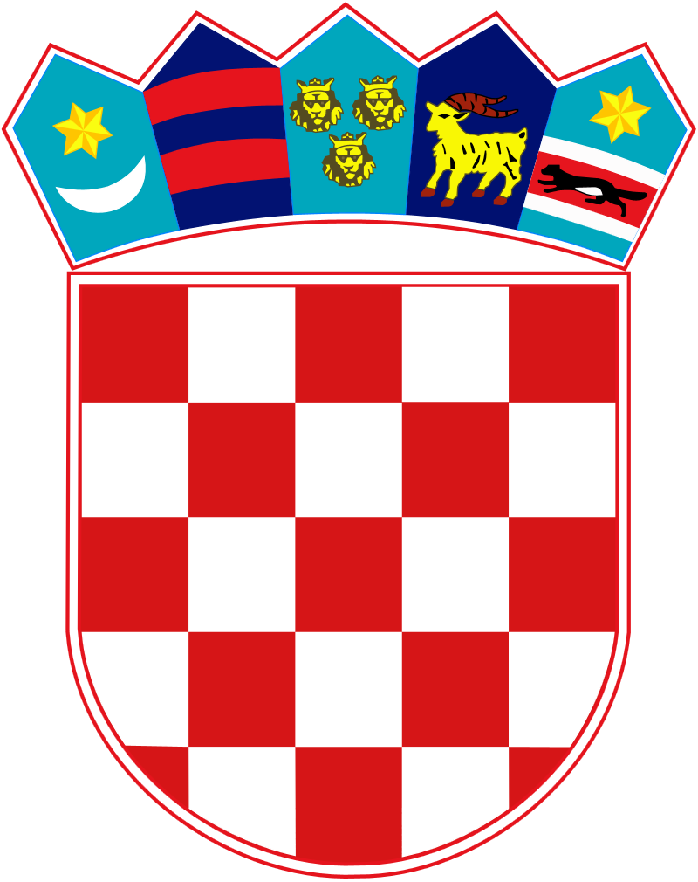

REPUBLIC OF CROATIA

MINISTRY OF DEMOGRAPHY AND IMMIGRATION

Based on Articles 33 and 60 of the Act on Relations of the Republic of Croatia with Croats Abroad (“Narodne novine”, numbers 124/11 and 16/12), Article 7, Paragraph 2 of the Act on Amendments to the Act on the Organization and Scope of the State Administration Bodies (“Narodne novine”, number 57/2024), and Article 7 of the Regulations on the Awarding of Scholarships for Learning the Croatian Language in the Republic of Croatia and for Online Learning of the Croatian Language (“Narodne novine”, number 54/19, hereinafter: Regulations), the Ministry of Demography and Immigration

announces a

P U B L I C C A L L
for the granting of scholarships for learning the Croatian language in the Republic of Croatia
for the academic year 2024/2025

1. TYPE AND CONTENT OF THE SCHOLARSHIP

The Ministry of Demography and Immigration (hereinafter: the The Ministry) grants for the academic year 2024/2025:

- up to 500 scholarships for learning the Croatian language in the Republic of Croatia (Zagreb, Split, Rijeka, Osijek, Zadar and Pula), which include the cost of the Croatian language course (hereinafter: the Course), the cost of subsidized meals up to two meals per day, and an accommodation allowance in a student dormitory or private accommodation of 300 euros per month.

The scholarship for learning the Croatian language in the Republic of Croatia is granted for one (winter or summer semester) or two semesters in the academic year 2024/2025. The winter semester is conducted from early October 2024 to the end of January 2025, and the summer semester from early March 2025 to mid-June 2025.

The scholarship includes:
- The cost of the Course.
- Subsidized meals up to two meals per day (via the x-ica meal card).
- Accommodation allowance in a student dormitory or private accommodation of 300 euros per month, which will be paid to the scholarship recipient who provides proof of successfully completing the enrolled semester.

The scholarship may include:
- Subsidized accommodation in a student dormitory at the location where the Course is held.

The scholarship does not include:
- Travel costs (to and from) the Republic of Croatia.
- Public transportation costs.
- Mandatory health insurance costs during the duration of the Croatian language course in the Republic of Croatia.

Note about the accommodation fee:

The accommodation allowance in a student dormitory or private accommodation is paid to the scholarship recipient after presenting proof of passing the final exam, proof of mandatory registration of residence or stay, or proof of approved residence in Croatia, a document showing the personal identification number (OIB), and a bank confirmation with the scholarship recipient’s account details in the Republic of Croatia.

Note on subsidized accommodation in a student dormitory:

The number of available places in the student dormitory is limited and approved by the Ministry of Science and Education. Scholarship recipients with the highest scores in the public call and who are not older than 33 years on the day of the announcement of the public call will have priority for obtaining accommodation in the student dormitories.

2. INSTITUTIONS AND LOCATIONS FOR CONDUCTING THE CROATIAN LANGUAGE COURSE

The institutions that conduct the Course are the Faculty of Philosophy in Zagreb, Split, Rijeka, Osijek, Pula and the University of Zadar which establish the obligations and rights of the students of the Course.

The applicant, during the application process, must choose the first and second location to attend the Croatian language Course.

The approved location for attending the Course is an integral part of the Decision on granting the scholarship for learning the Croatian language in the Republic of Croatia.

3. REQUIREMENTS FOR SUBMITTING THE APPLICATION

Any adult (18+) with completed secondary education who is:

- a member of the Croatian people outside the Republic of Croatia or their descendant.

- the spouse of a member of the Croatian people outside the Republic of Croatia.

- a friend of the Croatian people and the Republic of Croatia who cultivates the Croatian identity and promotes Croatian cultural cohesion.

The persons from the above categories have the right to apply if they have residence outside the Republic of Croatia or if they have resided in the Republic of Croatia for no more than three years until the date of publication of this public call.

4. CRITERIA FOR SCORING FOR THE GRANTING OF THE SCHOLARSHIP

The scholarship is awarded based on the points obtained according to the following criteria:

N | CRITERIA | POINTS
1. | Candidate's achievements and motivation:  - Highest motivation  - High motivation  - Medium motivation  - Low motivation | 35  30  20  10
2. | Active membership in the community/association of the Croatian minority or Croatian emigrants | 15
3. | Security position of the Croatian community member in the country of residence | 15
4. | Successfully completed semester of the Croatian language in the Republic of Croatia in the previous academic year | 15
5. | Residence of a close family member (spouse, child, parent, brother or sister) in the Republic of Croatia for no more than three years | 10
6. | Higher education obtained | 5
7. | Residence in a country outside Europe | 5

5. MANDATORY DOCUMENTATION

To demonstrate compliance with the prescribed conditions and criteria, the applicant must submit the following documentation from points 1 to 7:

1. Proof of the applicant:

- Applicant - Member of the Croatian people outside the Republic of Croatia or their descendant

Proof of belonging to the Croatian people for the member of the Croatian people outside the Republic of Croatia:

- Document proving that the applicant is a member of the Croatian people

Proof of belonging to the Croatian people for the descendant of a member of the Croatian people outside the Republic of Croatia:

- Document proving that the applicant is a descendant of a member of the Croatian people or a Croatian emigrant

NOTE: The applicant who is a descendant of a member of the Croatian people or a Croatian emigrant, in order to prove their belonging to the Croatian people, is required to provide evidence of the continuity of kinship with their ancestor who was a member of the Croatian people.

Additional documentation that the applicant may submit along with the proof of belonging to the Croatian people:

- Certificate from the head of the relevant diplomatic mission/consular office of the Republic of Croatia or the Croatian Catholic mission or the association of the Croatian minority/emigrant abroad
- Excerpt from a published article (in the press, books, brochures, or on the internet) that credibly mentions the Croatian origin of the mentioned person (candidate or their ancestor) or their Croatian activities and commitments.
- Resolution on the acquisition of Croatian citizenship (Rješenje).

- Applicant - Spouse of a member of the Croatian people outside the Republic of Croatia

Proof of belonging to the Croatian people for the spouse of a member of the Croatian people outside the Republic of Croatia:

- Proof of belonging to the Croatian people for the spouse of the applicant (as mentioned under A. Applicant, member of the Croatian people outside the Republic of Croatia or their descendant)
- Marriage certificate
- Birth certificate of the applicant's spouse
- Proof of residence of the applicant's spouse

- Applicant - Friend of the Croatian people and the Republic of Croatia who nurtures the Croatian identity and promotes Croatian cultural unity:

- Written statement or recommendation from the head of the relevant diplomatic mission/consular office of the Republic of Croatia or the association of Croatian emigrants in the country of origin about the applicant's activities in promoting the interests of the Croatian people and the Republic of Croatia, and nurturing the Croatian identity and promoting Croatian cultural unity.

2. Birth certificate of the applicant
3. Valid passport of the applicant
4. Proof of residence of the applicant:
- Proof of residence outside the Republic of Croatia: identification document or other document from the country of origin showing the address of residence (only for applicants outside the Republic of Croatia)
- Proof of residence in the Republic of Croatia: valid Croatian identity card or biometric residence permit or certificate of residence registration (only for applicants who have registered residence in the Republic of Croatia no longer than three years from the date of publication of the public call).
Note: the applicant who is the spouse of a member of the Croatian people must provide proof of residence for themselves and for their spouse.
5. Certificate or diploma of the highest completed level of education of the applicant
6. Certificate from the competent authority of the country of residence stating that there are no ongoing criminal proceedings against the applicant and/or copy of the certificate of no criminal record, not older than six (6) months from the date of publication of this public call. All candidates who have resided in the Republic of Croatia for more than 6 months from the date of publication of this public call must submit this certificate issued in the Republic of Croatia.
7. Applicant's statement of consent for the collection, processing, and publication of personal data, personally signed by the applicant.

6. ADDITIONAL DOCUMENTATION

To obtain additional points according to the evaluation criteria, the applicant can submit:

- Certificate of the last successfully completed semester of the Croatian language course in the Republic of Croatia.

- Certificate that the applicant is an active member of an association of the Croatian minority or Croatian emigrants or a copy of another document demonstrating that the applicant is an active member of the Croatian community.

- Documents to demonstrate the residence of a close family member in the Republic of Croatia.

7. MODE AND DEADLINE FOR SUBMITTING THE APPLICATION

The application must be submitted electronically via the electronic application form together with the attachments.

The e-application form can be found on the website of the Ministry of Demography and Immigration and the Central State Office for Croats Abroad via the link:
https://eprijave-hrvatiizvanrh.gov.hr/.

The motivation letter is an integral part of the electronic application form and should contain at least 250 words.

The deadline for submitting the e-application is 30 (thirty) days from the date of publication of the Public Call on the Ministry's website and ends on July 11, 2024, after which it will no longer be possible to submit the e-application or upload documentation.

Applications with incomplete documentation or applications/supplements to applications that are not submitted within the deadline and in the manner prescribed by this Public Call will not be considered.

8. PROPOSAL OF THE SCORE LIST AND DECISION-MAKING

The public call is managed by the Commission for the execution of the public call for granting scholarships for learning the Croatian language in the Republic of Croatia and for online learning of the Croatian language (hereinafter: the Commission).

After reviewing and considering all correctly submitted applications in the public call, the Commission establishes the proposed score list for learning the Croatian language in the Republic of Croatia according to the terms and criteria of the public call.

The proposed ranking list for learning the Croatian language in the Republic of Croatia will be published on the Ministry's website within 30 (thirty) days from the application deadline and will contain the following information: candidate's name and surname, year of birth, country of residence, place of attendance of the Course, semester of the academic year, total number of points achieved by the candidate.

Within 8 (eight) days from the date of publication of the proposed ranking list for learning the Croatian language in the Republic of Croatia, the applicant may submit a written complaint to the Ministry.

The Commission reviews complaints received within the deadline and, no later than 30 (thirty) days from the expiration of the complaint period, proposes to the Minister the final ranking list for learning the Croatian language in the Republic of Croatia.

Upon completion of the procedure for the received complaints, based on the Commission's proposal, the Minister issues the Decision on the awarding of scholarships for learning the Croatian language in the Republic of Croatia, which includes the final ranking list for learning the Croatian language in the Republic of Croatia. Based on this, a scholarship agreement is concluded with the scholarship recipient, detailing the rights and obligations of the scholarship provider and recipient.

9. ADDITIONAL INFORMATION

For any further questions or clarification, applicants can contact the official email address: stipendije@mdu.hr.

CLASS: 015-09/24-01/1
NUMBER:519/1-24-1

Zagreb, June 11th, 2024

M I N I S T E R

Ivan Šipić

NOTE: Courtesy translation only

